**Chapter 2**

**Overview about Healthy Shield**

# 2.1 Introduction:

In this chapter we will discuss the medical and healthcare systems that similar to the system in our project. This chapter has 7 sections starting with introduction and ending with related projects. We will take about its publisher and history of it. [1]

# 2.2 History of project

# EPIC: Epic focuses on large medical groups and inpatient settings , EPIC’s software is mainly used in large health systems , community hospitals and academic medical centers.



2.1 Logo for Epic Healthcare and medical system.

Cerner: Cerner is currently the leading supplier of Health IT solutions and are the largest provider of systems for inpatient care. They support specialists along with the clinical , financial and operational needs of medium and large organizations.

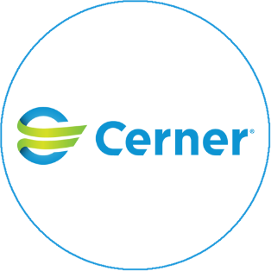

2.2 Logo for Cerner Healthcare and medical system.

CareCloud: CareCLoud provides award-winning Electronic Health Record and Patient Experience Management , Its considered as a leading provider of cloud-based revenue cycle management services for ambulatory care practices.

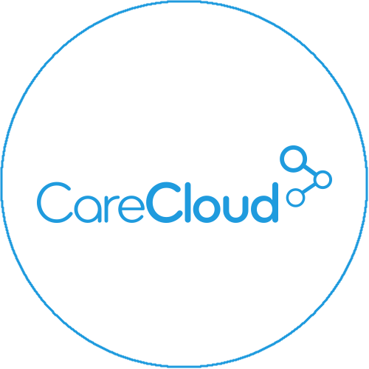

2.3 Logo for CareCloud Healthcare and medical system.

AthenaHealth: AthenaHealth offers a cloud-based revenue cycle solution geared towards large, multi-physician groups and hospitals . They offer a more modern user interface and some cloud-based capabilities like access from any browser.

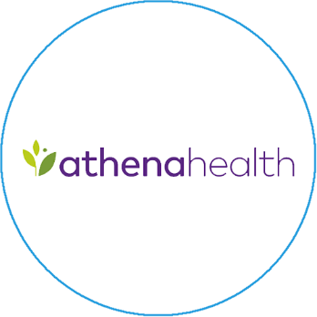

2.4 Logo for AthenaHealth Healthcare and medical system.

# 2.3 References

1. https://www.carecloud.com